**Advanced Used Car Bidding System**

Group 8: Qinhao Zhang, Anning Tian, Pingyi Xu, Xinmeng Wu

Khoury College of Computer Sciences, Class: CS5200

Dr. Tehmina Amjad

Jan.28 2024

**Abstract**

The Advanced Used Car Bidding System represents a pivotal step in online auction platforms, specifically tailored for the used car market. This project has integrated a robust database system with real-time auction functionalities. Key points from this venture include the crucial understanding of diverse user roles and their needs, the intricacies of melding real-time data with various system functionalities, the implementation of stringent security measures, and the importance of an intuitive and accessible user interface. The development process has highlighted the necessity of database maintenance, the value of incorporating user feedback, and the importance of scalable system design to accommodate future growth. This project stands out as a comprehensive educational journey, emphasizing a user-centric approach in developing a sophisticated and efficient online platform for car auctions.

**Problem Statement**

Basic requirements:

1. **User Role Definition**: Two types of users - "Admin" and "Normal" users. Admin users can manage the entire system, so can access any data. In addition, admin users can access daily and weekly reports. Normal users can act both as "sellers" and "bidders".
2. **Registration and Login for Users**: Enable "Normal" users to register and sign into the system, providing a user-friendly interface specific to used car auctions.
3. **Listing of Used Cars**: Allow "Normal" users (as sellers) to post listings of used cars, requiring details like make, model, year, mileage, condition, and vehicle history.
4. **Bidding Functionality**: Permit "Normal" users (as bidders) to place bids on listed used cars, with an interface showing detailed information about each car and current bid status.
5. **Offline Payment Options**: Implement a system to handle offline payments for car purchases, such as personal checks or bank transfers.
6. **Shipping Integration with Tracking**: Integrate a shipping solution for used cars, complete with the generation of tracking numbers, preferably with options for different carriers, including UPS.
7. **Rating System for Transactions**: Enable both sellers and buyers to rate each other post-transaction, focusing on aspects like car condition accuracy, payment promptness, and overall transaction satisfaction.
8. **User Profile Access**: Ensure all users can access user profiles, which should include history and details of cars listed or bid on.
9. **Messaging for Auction-related Inquiries**: Allow "Normal" users to message each other regarding specific details or queries related to the used car being auctioned.
10. **Communication Channel between Users and Admins**: Facilitate a messaging system where "Normal" users can report issues or seek assistance from "Admin" users regarding auction items.
11. **Comprehensive Admin Dashboard**: Empower Admin users with a dashboard to oversee the entire system, manage user accounts, access auction data, and generate detailed reports.
12. **Car Verification and History Reports**: Integrate tools for verifying car history and condition, ensuring transparency and trust in the auction process.
13. **Real-time Auction Updates:** Implement real-time notifications and updates for users involved in an auction, such as bid status, auction ending soon alerts, and outbid notifications.
14. **Sales Record Management**: The system maintains a comprehensive sales record for each transaction, capturing all relevant details such as the car sold, sale price, buyer and seller information, and the date of sale.
15. **Trading Information Management**: The system shall provide a trading information management feature that consolidates all trade-related data, including bid history, auction outcomes, and user transaction records, to support effective decision-making and reporting.
16. **Integrated Payment System**: The system shall incorporate an integrated payment system that enables secure online financial transactions. The security protocols that will be in place to protect online transactions.
17. **Order Notification**: The system shall automatically generate and send order notifications to users, informing them of the status of their purchases, sales, and any changes in the auction status of items they are interested in.
18. **Shipping Carrier Integration**: The system shall integrate with various shipping carriers and provide users with options to select their preferred shipping service.

Extra requirements:

1. **Virtual Car Tours**: Integrate a feature allowing sellers to upload virtual tours of cars, including 360-degree interior and exterior views, to provide a comprehensive visual experience for bidders.
2. **Automated Fraud Detection System:** Develop an automated system to detect and prevent fraudulent activities, such as fake bids or misrepresented car conditions.
3. **Auction Watchlist and Notifications:** Allow users to add cars to a watchlist and receive notifications about specific cars they are interested in, such as price drops or auction end times.
4. **Environmental Impact Rating:** Include an environmental impact rating for each car, providing information on fuel efficiency and emissions, to aid environmentally conscious decisions.
5. **Online Payment for Users with Good Credit**: The payment system allows for online transactions for users who have established a good credit standing.

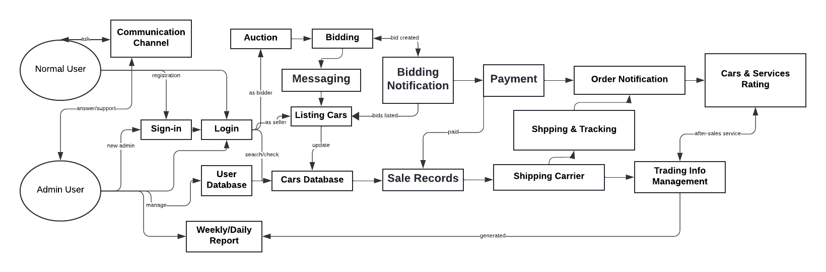

**Realistic Queries**

1. Extract the data that cars have received the highest bids in the past week.

**Purpose:** Help to understand the marketing trends, find the most popular cars/vehicles in the market, help to improve the user feeding experience

1. Compare the past 6 months selling price of different types of vehicles (ex. Sedans, pick-up, minivan, suv, etc.).

**Purpose:** analyze the marketing price of different types of vehicles, help understand the marketing needs, shortages (when some types of vehicles price go higher than usual, it may face the marketing shortage.). Understand the pricing strategies.

1. Display the total value of transactions completed in each of the last three months, broken down by car category (e.g., sports, SUV, sedan).

**Purpose:** Analyze the sales performance across different car categories

1. Find all users who have placed bids on more than five luxury cars but have never won an auction.

**Purpose:** Identifies potential high-value customers for targeted marketing or outreach.

1. Show the list of all auctions where the winning bid was at least 20% higher than the average bid for that car model.

**Purpose:** Detects auctions with unusually high bidding activity, avoided for money laundry, fake bidding actions, and analyzes the reason.

1. Retrieve a list of all cars that have a discrepancy between the listed mileage and the mileage reported in the vehicle history.

**Purpose:** Ensures accuracy and trustworthiness of listings, helping find scams and frauds.

1. Extract users have a bidding success rate of over 70%.

**Purpose:** Identifies highly successful bidders, potentially for premium services or rewards.

1. List all-electric cars that have been auctioned with a reserve price but remained unsold.

**Purpose:** Understand market interest in electric cars and pricing strategies.

1. Get the data on the average time taken for different car models to sell, from listing to closing of auction.

**Purpose:** Provides insights into the liquidity of different car models in the market.

1. Show the number of international bidders participating in auctions, broken down by country.

**Purpose:** Assesses global reach and international interest in the auction platform.

1. Identify all users who have changed their bid in the last 5 minutes of an auction more than three times in the past month.

**Purpose:** Detects patterns in bidding behavior, possibly indicating a need for system improvements.

1. List all cars that have a history of more than two owners and are currently listed at a price below the market average.

**Purpose:** Helps bidders find potentially undervalued deals.

1. Extract auctions where the reserve price was not met, including the highest bid received and the reserve price set.

**Purpose:** Assists sellers in reevaluating their reserve prices.

1. Identify all cars that have been relisted more than twice without a successful sale.

**Purpose:** Helps to identify cars that might be having issues in attracting bidders, possibly due to pricing or listing quality.

1. List the top 10 most active bidders this month and the types of cars they have bid on.

**Purpose:** Useful for understanding bidder preferences and engagement levels, which can inform marketing and promotion strategies.

1. Collect user privacy preference.

**Purpose:** analyze the user privacy preference to better improve security of user data, and enhance the special feeding strategies

1. Collect user reported issues regarding application, bidding function, etc..

**Purpose:** Understand the existing problem of application and better improve the user experience.

**Entity, Attribute, and Relationship**

1. **User** (User ID, SSN, Gender, Age, Email, Phone Number, User Type)

Different users will be managed by different Admin, users can bid or sell more than one car, and users also give different bids at different times. Users not only can have different orders, but also start different auctions, generate different payments, and select different shipping. They are all M: N relationships. Also, the user can be split into subclasses- Seller and Bidder, and it is also M: N relationship- the Comment/ Rate relationship.

1. **Car** (VIN, Make, Model, Fuel, Year, Price, Body Type, Exterior Color, Interior Color, Capacity)

Cars are managed by Admins, and each car will have its reports. For different cars, it can be transported in different shipping. They are all M: N relationships.

1. **Admin** (Account ID, Department, Salary, Company )

Admin can manage Users and Cars. Both are M: N relationships.

1. **Auction**: (Auction ID, Start Time, End, Time, Starting Bid, Reserve Price, Auction Status)

The Auction will be started by Users - M: N relationship. And the result depends on the Bid, a 1: 1 relationship. Finally, the auction result will influence the Order, which is a 1: 1 relationship.

1. **Bid**: (Bid ID, User ID, Auction ID, Bid Amount, Bid Time)

Different Bids could be given by different Users, which is a M: N relationship. And, the final Bid will determine the Auction, a 1: 1 relationship.

1. **Payment**: (Payment ID, User ID, Amount, Payment Method, Payment Status)

Every User can generate different Payments, and it is a 1:N relationship.

1. **Order**: (Order ID, Time, Price, Payment Method, Buyer, Seller)

Each order is determined by each auction (1:1) and many orders can be held/belong to one user (N:1).

1. **Shipping**: (Tracking Number, Shipping Method, Shipping Status)

Many shippings can be created by many users (N: M) and many cars can be transported by many shippings (N: M).

1. **Report**: (Report ID, Ownership History, Title History, Additional History, Detail History)

Each report corresponds to each car (1:1), and each report can be extracted by many users (1:N).

**Assumptions**

1. **Users must register for bidding:**

Only registered users can bid, sell, or participate in auctions, which ensures each action in the system can be traced back to a verified user.

1. **Unique username, email, and phone number:**

Each user's username, email address, and phone number are unique within the system to ensure clear communication channels.

1. **Admin privileges:**

Admin users have special privileges that allow them to access and maintain data, manage auctions, and oversee user activity.

1. **Auction constraints:**

Each auction for a car is time-bounded, meaning it has a definite start and end time, and cannot be altered once it begins.

1. **Bid uniqueness:**

Each bid is considered unique and is identifiable by a Bid ID, which can be used to track bidding history and show the rank by bidding price.

1. **Bid increment rules:**

Bids must follow predefined increment rules, meaning each subsequent bid must be at least a certain amount equal to or higher than the current highest bid.

1. **Payment verification:**

All payments need to be verified before the transaction is marked as complete and the item is shipped.

1. **Immutable bid history:**

Once a bid is placed, it cannot be modified or deleted to maintain the integrity of the auction process.

1. **Shipping after payment:**

Items are only shipped after payment has been confirmed, linking the payment and shipping processes.

1. **Feedback anonymity:**

Feedback has an anonymous option to encourage honest reviews while protecting user privacy.

1. **Report accuracy:**

Reports generated by the system, such as ownership or title history, are assumed to be accurate and up-to-date, reflecting the true status and the market trend of the car.

1. **Single winner per auction:**

Each auction results in only one winner, the highest bidder who meets or exceeds the reserve price at the auction's close.

1. **Reserve price privacy:**

The reserve price of an auction is not disclosed to the bidders to maintain competitive bidding.

1. **Auction item uniqueness:**

Each car can only be listed in one auction at a time to prevent double-selling.

1. **Binding bids:**

Placing a bid constitutes a binding agreement to purchase the item at the bid price if it wins the auction.

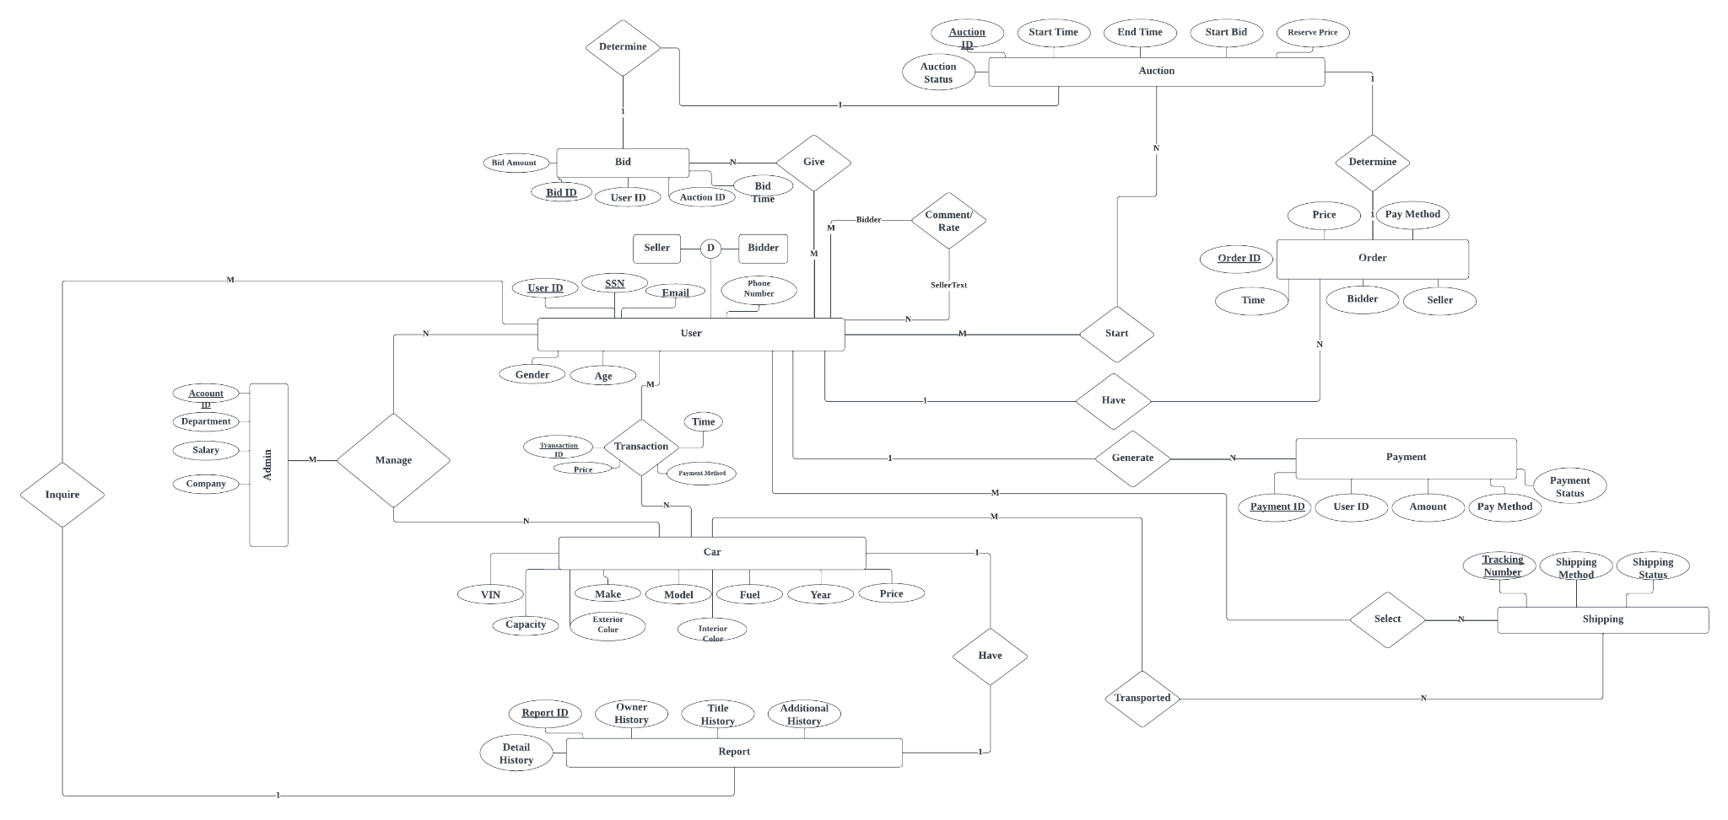

**Conclusion**

Qinhao Zhang:

Throughout this phase of development of the Advanced Used Car Bidding System, I've gained invaluable insights into the complexities of designing and integrating online auction with a database platform by using tools, such as ER model and UML. Key learnings include the importance of understanding diverse user roles, the challenges of integrating real-time data and multiple functionalities, the criticality of robust security measures, and the significance of an intuitive user experience. Looking forward, I recognize the need to focus on areas such as enhancing data analytics, improving the generation of market trends, integrating user feedback more effectively, and planning for scalability. This project has been a profound learning experience, emphasizing the need for a user-centered approach and highlighting the intricacies of developing a comprehensive and efficient online marketplace.

Anning:

In project phase one, I learned the importance of team cooperation, and I also learned how to better communicate with my team members. I now have a deeper understanding of the database system, for example, how to set entities, weak entities, and relationships, how to design the queries and fulfill the bidding requirements for a database and an application. I know more about how to break down a big point into several smaller points so it can be more detailed and help more in database designing. In the future, I will try to improve our team communication and be involved in more teamwork.

Xinmeng Wu:

In our project, I extensively researched car bidding websites, gaining deep insights into their processes. This was complemented by exemplary teamwork and cooperation within our group. Each of us, responsible and supportive, not only fulfilled our individual roles but also actively assisted others. We tackled challenges by brainstorming multiple solutions at each step, ensuring a comprehensive approach. Ultimately, the best ideas were amalgamated into our final submission. This experience underscored the importance of thorough research and collaborative problem-solving in achieving successful outcomes in a complex, dynamic industry.

Pingyi Xu:

In the first phase, we gained a deeper understanding of the car bidding process and pinpointed several areas for improvement. We applied the ER model, a tool we've studied in our coursework, to clarify and refine the bidding procedure. This not only improved our proficiency with the ER model but also enriched our experience in crafting more sophisticated databases. Initially, there was a diversity of opinions within our team regarding the realistic queries. Through discussion, we came to a consensus. This has established a strong foundation for effective teamwork as we continue to advance the project.